Global Educational Enrollment Dashboard(2016,2019)

Introduction
In this project, World Bank Open Data dataset was used to perform analysis on educational enrollment.
The purpose of this study was to examine and compare the student enrollment at various education levels in a number of selected countries; Qatar, Jordan, Oman, China, India, and Georgia, over the period 2016 – 2019.

Dataset Description
The dataset consists of the number of enrollments in education for three key education indicators:
- Enrolment in primary education
- Enrolment in secondary education
- Enrolment in tertiary education
Countries used in the analysis:
Qatar , Jordan , Oman , China , India , Georgia
Time period:
2016-2019

Preprocessing
To guarantee quality and consistency of the data, the following procedures were applied:
- Numeric Conversion: Numeric columns were converted to whole numbers.
- Custom Imputation: To keep geographical data integrity, missing values in numerical columns were imputed with the mean of each country (row).
- Data Restructuring: The multi year columns were concatenated into one column to allow for time series analysis in Power BI.

Dashboard Features
- Dynamic Chart Titles (DAX Measure): In the charts themselves, instead of a static text, we created dynamic titles using a DAX measure. These titles are updated when slicer selections are applied (Country, Year, Level) so that the user can know precisely what data is being plotted.
- Basic Filtering Strategy:
- Filters on this page (Years(: Used to restrict the analysis to particular time periods within a single page.
- Filters on all pages (Series): Applied to keep selected level of education checked as user moves across dashboard.
- Interactive Slicers: The dashboard contains three main slicers (Years, Country, Series) which allow users to customize the view and analyze the data chunks in more detailed
Visualization
We created a two-page interactive dashboard in Power BI to study global education enrolment:
Page 1: Global Overview & Geography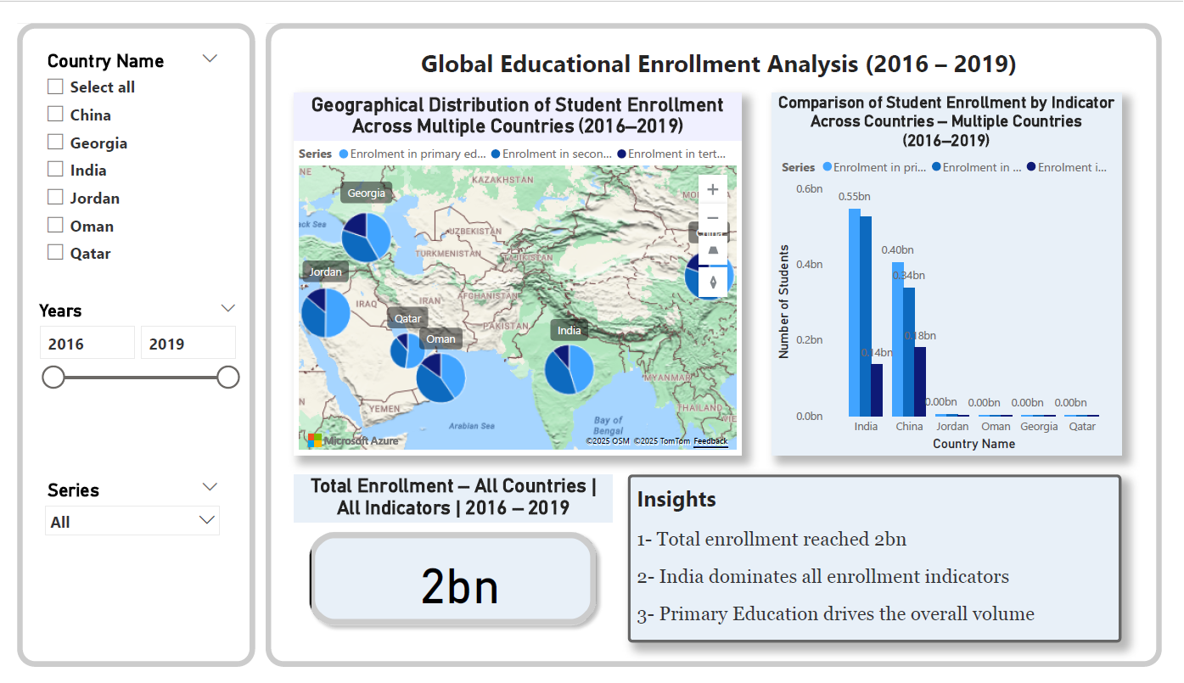
Explanation of the charts used:
- Bubble Map
It displays the geographical student enrollment of the selected countries.
The bubble size indicates the number of students, and the color indicates the Education Series (Primary, Secondary, or Tertiary).
When the user selects a particular country, year or education level, the map automatically updates, enabling a neat spatial comparison of student distribution and student levels.

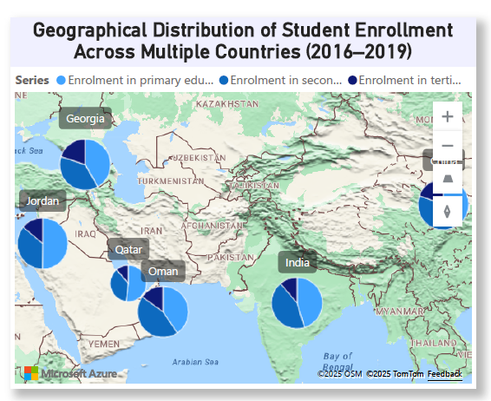

2- Column Chart:

It displays the number of students enrolled in various levels of education in a chosen country and year.
Consistent use of color for each Series enables the reader to quickly determine the highest and lowest levels of enrolment at a glance among the different countries.
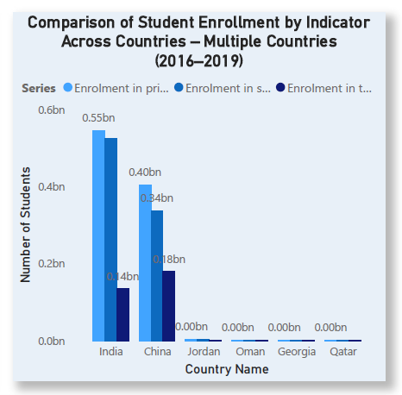

3- Data Card :
It shows a single value that is a summary, which is the total number of students for the applied filters.
This card gives a high level overview with the users able to know the total number of enrollments at a glance without having to study down to the detailed charts.
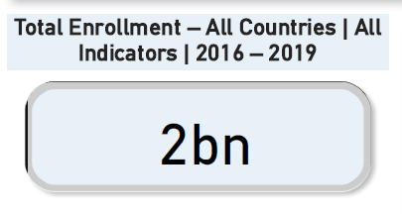

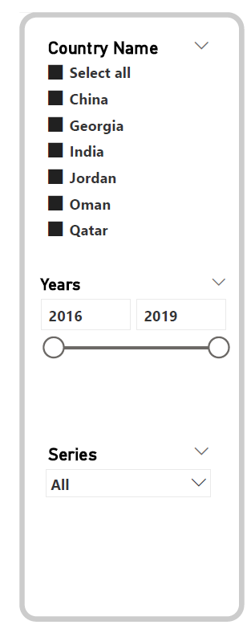
4- Slicers:

To choose a specific country or a specific year or indicator .

Page 2: Trend & Distribution Analysis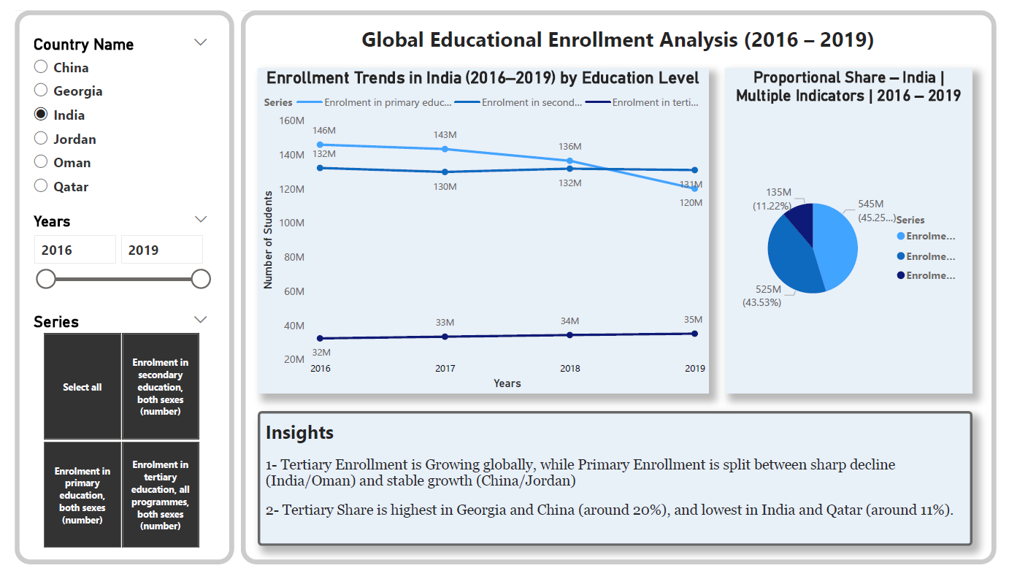
Explanation of the charts used:
- Line chart :
It displays the changes in the number of students who attended three levels of education, namely primary, secondary and tertiary, from 2016 to 2019.
It shows particular growths or declines at certain times in the past.
Users can also compare at time between countries and levels of education to observe patterns of growth in time.
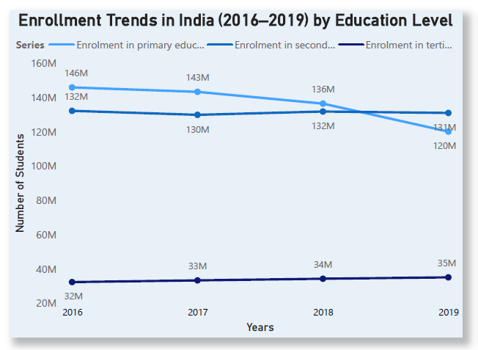

- Pie chart:
It shows the relative proportion of students in each of the three levels of education. This chart is a quick glance at how the total enrollment in education is distributed among levels (primary, secondary and tertiary ). Displaying the share of each category, it immediately allows the user to determine which is the most popular education level in terms of the share of enrollments for the country and the year selected.
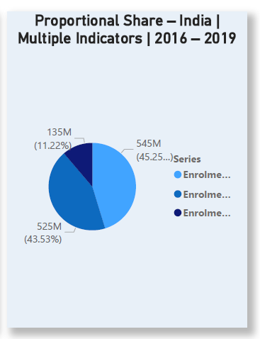

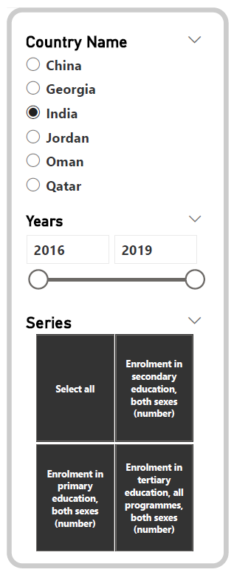
3- Slicers:

To choose a specific country or a specific year or indicator .

Summarization:
Based on the data presented, it is evident that the allocation of students across countries is highly imbalanced, whereas tertiary enrollment is increasing worldwide. As we were going through the dashboard, we saw that Georgia and China had the largest shares in higher education, at around 20%, indicating the importance of the elite universities in both countries.
In contrast, India and Oman experienced a drastic fall in Primary enrollment, which may be indicative of shifts in educational infrastructure or demographics in 2016–2019.
This interactive analysis reveals that the teaching method is influenced by the immediate needs of a country, and this is observable in the gap between the rates of primary and tertiary enrollment.

Conclusion:
With Power BI we could deliver a meaningful dashboard that allowed us to get full insights on these education metrics using only interactive visuals. So we could easily spot trends and compare them across regions, turning what could have been a monster table into a simple but effective visual story.

